Name
Instructor
Course
Date

Name: Stacy Evans
Date of Assessment: 1/1/2016

Target Behavior: Tantrum

RESULTS OF FUNCTIONAL ANALYSIS FOR STACY

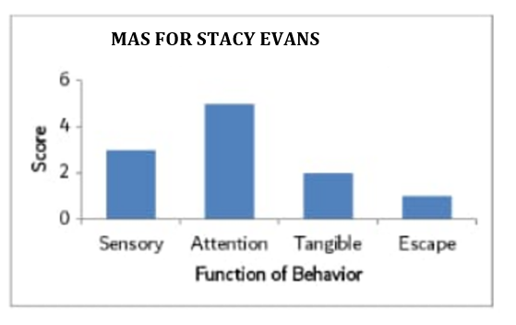

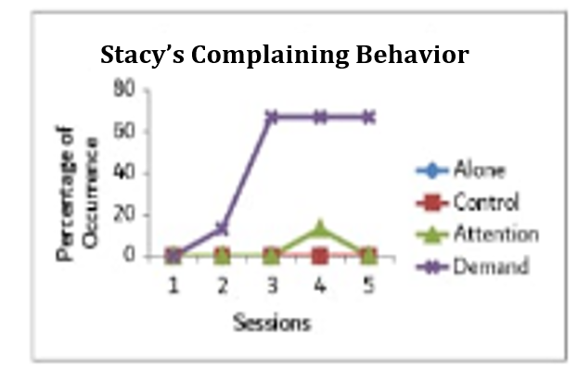

ALONE CONDITION

 | 0-9 seconds | 10-19 seconds | 20-29 seconds | 30-39 seconds | 40-49 seconds | 50-59 seconds | Percentage of Intervals
Minute 1 | -- | -- | -- | -- | -- | -- | 0%
Minute 2 | -- | -- | -- | -- | -- | -- | 0%
Minute 3 | -- | -- | -- | -- | X | -- | 17%
Minute 4 | -- | -- | -- | -- | -- | -- | 0%
Minute 5 | -- | -- | -- | -- | -- | -- | 0%

ATTENTION CONDITION

 | 0-9 seconds | 10-19 seconds | 20-29 seconds | 30-39 seconds | 40-49 seconds | 50-59 seconds | Percentage of Intervals
Minute 1 | -- | -- | -- | -- | -- | -- | 0%
Minute 2 | -X | X | -- | -- | -- | -- | 33%
Minute 3 | -- | -- | -- | -- | -- | -- | 0%
Minute 4 | -- | -- | -- | -- | -- | -- | 0%
Minute 5 | -- | -- | -- | -- | -- | -- | 0 %

BE SURE TO CALCULARE THE PERCENTAGE OF INTERVALS FOR THE PLAY AND ESCAPE CONDITION BELOW. THE PERCENTAGE OF INTERVALS SHOULD BE CALCULATED BELOW. THE ATTENTION AND ALONE CONDITION CHART ABOVE CAN BE USED AS AN EXAMPLE OF HOW TO CALCULATE THE PERCENTAGE OF INTERVALS.

PLAY CONDITION
 | 0-9 seconds | 10-19 seconds | 20-29 seconds | 30-39 seconds | 40-49 seconds | 50-59 seconds | Percentage of Intervals
Minute 1 | -- | -- | -- | -- | -- | -- | 0%
Minute 2 | -- | -- | -- | -- | -- | -- | 0%
Minute 3 | -- | -- | -- | -- | -- | -- | 0%
Minute 4 | -- | -- | -- | -- | -- | -- | 0%
Minute 5 | -- | -- | -- | -- | -- | -- | 0%

ESCAPE CONDITION

 | 0-9 seconds | 10-19 seconds | 20-29 seconds | 30-39 seconds | 40-49 seconds | 50-59 seconds | Percentage of Intervals
Minute 1 | -- | -- | X | X | -- | -- | 33%
Minute 2 | X | -- | -- | -- | -- | -- | 17%
Minute 3 | -- | -- | -- | X | -- | -- | 17%
Minute 4 | X | X | X | -- | X | -- | 67%
Minute 5 | X | X | X | -- | X | X | 84%
Causes of Tantrums
A tantrum is the statement of a young kid's dissatisfaction with the difficulties existing apart from everything else. Maybe your child is experiencing difficulty making sense of something or finishing a particular task. Possibly your youngster cannot discover the words to express his or her considerations or emotions. Whatever the test, disappointment with the circumstance may trigger indignation
A few reasons children who have tantrums incorporate the following:
Your child needs to be without anyone else, and get agitated when he can't do what he needs.
Your child is attempting to get regard for test the standards.
Your child has something detracted from him.
Your child has not adapted every one of the words to disclose to you what he feels or needs, and this surprises him.
Your kid does not comprehend what you need him to do.
Your kid is drained or hungry.
Your kid is concerned or upset.
Your youngster feels worry in the home.
Results and Discussion
The analysis in this case is based on the interview conducted whereby the main character is Stacy Evans and was done practically for accirate results to be obtained. The charts indicate the level of preliminaries with major concernon on both the pre-and posttransition times of every change associated with the characters. The progress that occasioned fits regularly for Stacy was end of the actions she favored most. In this way, this change was picked as the objective progress amid the treatment assessment. Wear displayed tantrums frequently amid the pretransition time of the nonpreferred movement end condition. What's more, Stacy occupied with a tantrums amid two of three posttransition periods in the nonpreferred movement end condition. Subsequently, Stacy's tantrums happened only when she was getting or was approached to get the paper. Get commencement was in this manner picked as Stacy's objective change for the treatment assessment.
The graphs provided demonstrate the level of preliminaries with tantrums amid the treatment assessment. It is identified that Stacy's tantrums happened amid 100% of gauge and notification ahead of time preliminaries. Several steps taken in eradication of tantrums step by step caused it to diminish.
Results recommend that concise utilitarian examination strategies can be utilized to recognize the supporting factors for high tempered conduct related with changes shown by ordinarily creating preschool kids, in this manner giving a model to outpatient evaluation and treatment of tantrums related with advances. Additionally, despite a few examinations, it has been discovered that notification ahead of time of an up and coming change can lessen abnormal conduct. One contrast between the present examination and the FAST that may represent the discrepant outcomes is that notification ahead of time was given after the movement had started in the FAST consider.
The technique of this examination is particular from standard utilitarian investigations in that upgrade change was inspected in the two ways which were, favoring action to no other and making no movement to favored action. Different examinations have inspected change among nothing and access to a thing. Favored things were given, expelled, and returned at different occasions, organizing advances in the two bearings. The present examination varies in that changes in the two headings were customized autonomous of reacting, while all the more regularly, the advances comparable to the end progress are modified dependent upon the progression of time and the advances undifferentiated from the inception advances happen just dependent upon the objective conduct. Subsequently, in contrast to standard investigations, this examination permits examination of conduct that outcomes in an arrival to no action, no consideration.
It ought to be noticed that Stacy's tantrrums were maybe less identified with making a progress than to just getting away from the situation. That is, on the grounds that Stacy displayed fits in both the posttransition time of nonpreferred action inception and the pretransition time of nonpreferred movement end, escape from the errand itself, instead of a progress essentially, may have been keeping up his conduct. It ought to likewise be noticed that since Stacy's fits of rage never reached the annihilation part of the mediation. Future research ought to straightforwardly look at the impact of principles when leading utilitarian examinations and capacity based medicines with verbally capable members. A last confinement of the examination is that the impacts of area change were not surveyed.
Stacy has five triggers that lead her to having tantrums. The trigger that causes the most practices is when requests are set on Stacy, for example, non-preferred engagements or activities, for example, scrubbing down or when requested to eat her vegetable by parents. Tantrums likewise happen when Stacy is changing from what she likes to what she does not like. There is high rate of practices when Stacy needs access to unmistakable things, similar to food, and toys. For instance, if the parents reveal to her that she can't carry the teddy bear while interacting with others from the community. Half of the time the tantrum when ceasing if Stacy is offered access to the things she needs.
Tantrum treatment
Most youngsters learn different approaches to manage their anger and other compelling feelings as they become more established and need not bother with restorative treatment for tantrums. Overlooking the tantrums conduct and helping a youngsters figure out how to deal with his or her emotions is frequently all that is required.

Child rearing workshops can be useful for parents of children with tantrums. These kind of projects regularly help guardians become acquainted with development and formative stages and give systems on the best way to deal with troublesome conduct.
For instance we take a gander at when the fits of rage began and the kind of triggers that generally set the youngster off. We need to comprehend what they do when they are irate and what they look like (red face, white face, coated eyes, expanded quality), to what extent it brings to quiet them down and what happens afterwards. Not each little child pitches a fit and few out of every odd adolescent needs a frame of mind alteration. These issues are specific to the individual and are indications to which we should give our complete consideration. They mirror a quirky identity that can be guided and conveyed to its best state through homeopathic cures. Homeopathy is delicate and won't change your youngster's identity. At the point when the cure is picked accurately, it will bring your youngster into parity both physically and inwardly.

